Use Case: Setting up Transit Gateway and VPC Endpoints for a Multi-VPC Architecture
Scenario:
A large organization is migrating its on-premises infrastructure to the AWS cloud.
The organization's architecture involves multiple VPCs for different departments and applications, each requiring secure communication with centralized services and external resources.
The IT team needs to design and implement a scalable and efficient network architecture to accommodate the organization's growth and ensure robust connectivity between VPCs and external services.
Objectives:
- Design and deploy a scalable network architecture using AWS Transit Gateway to simplify network connectivity between multiple VPCs.
- Configure VPC endpoints to securely access AWS services without internet gateways or NAT gateways, ensuring data privacy and minimizing exposure to external threats.

An AWS Transit Gateway (TGW) is a central networking hub that connects multiple VPCs and on-premises networks together.
Instead of creating many VPC peering connections between VPCs, all VPCs connect to a single Transit Gateway.

Simple Diagram
Transit Gateway
|
---------------------------------
| | |
VPC-A VPC-B VPC-C
| | |
EC2s EC2s EC2s
All communication between VPCs passes through the Transit Gateway.

Why Do We Need Transit Gateway?
Suppose an organization has 5 VPCs.

Without Transit Gateway
You need multiple VPC peering connections:
VPC-A ↔ VPC-B
VPC-A ↔ VPC-C
VPC-A ↔ VPC-D
VPC-A ↔ VPC-E
VPC-B ↔ VPC-C
VPC-B ↔ VPC-D
...
This creates a complex mesh network that is difficult to manage.

With Transit Gateway
Transit Gateway
|
--------------------------------
| | | |
VPC-A VPC-B VPC-C VPC-D
Each VPC creates only one attachment to the TGW.

Key Components

1. Transit Gateway
The central routing hub.
TGW
It receives traffic and forwards it to the correct destination VPC or VPN.

2. VPC Attachment
Connects a VPC to the Transit Gateway.
VPC ---> TGW Attachment ---> Transit Gateway
Every VPC must have a TGW attachment.

3. Transit Gateway Route Table
Controls how traffic is routed between attachments.
Example:
Destination Attachment
10.0.0.0/16 Prod-VPC
10.1.0.0/16 Dev-VPC
10.2.0.0/16 Test-VPC

How Transit Gateway Works

Example

Production VPC
CIDR: 10.0.0.0/16

Development VPC
CIDR: 10.1.0.0/16

Transit Gateway
Attached to both VPCs

Route Table in Production VPC
Destination Target
10.0.0.0/16 Local
10.1.0.0/16 TGW

Route Table in Development VPC
Destination Target
10.1.0.0/16 Local
10.0.0.0/16 TGW

Traffic Flow
EC2 (Prod)
|
v
Transit Gateway
|
v
EC2 (Dev)

Transit Gateway with On-Premises Network
Transit Gateway can also connect AWS to an on-premises data center.
On-Premises
|
VPN / Direct Connect
|
Transit Gateway
/ | \
VPC1 VPC2 VPC3
This creates a centralized hybrid network.

Steps to Create a Transit Gateway

Step 1: Create Transit Gateway
- Open AWS Console
- Go to VPC
- Click Transit Gateways
- Click Create Transit Gateway
Example:
Name: Company-TGW
ASN: 64512
DNS Support: Enable

Step 2: Create Attachments
For each VPC:
- Select Transit Gateway Attachments
- Create Attachment
- Select VPC
- Select subnets
Example:
Attachment Name: Prod-Attachment
VPC: Production-VPC
Subnet: us-east-1a

Step 3: Update VPC Route Tables
Example:
Destination Target
10.1.0.0/16 Transit Gateway
10.2.0.0/16 Transit Gateway

Step 4: Configure TGW Route Table
Example:
Destination Attachment
10.0.0.0/16 Prod-Attachment
10.1.0.0/16 Dev-Attachment
10.2.0.0/16 Test-Attachment

Step 5: Test Connectivity
From an EC2 instance:
ping 10.1.1.100
or
telnet 10.1.1.100 22
Traffic should flow through the Transit Gateway.

Advantages of Transit Gateway

1. Centralized Connectivity
One hub connects all VPCs.

2. Simplified Management
No need for multiple VPC peering connections.

3. Scalable
Easy to add new VPCs.

4. Hybrid Cloud Support
Connects:
- VPCs
- Site-to-Site VPNs
- AWS Direct Connect

5. Better Routing Control
Central route tables manage traffic flow.

Transit Gateway vs VPC Peering
Feature | Transit Gateway | VPC Peering
Connectivity Model | Hub-and-Spoke | One-to-One
Scalability | High | Limited
Route Management | Centralized | Distributed
Transitive Routing | Supported | Not Supported
Suitable For | Many VPCs | Few VPCs

Real-Time Example
A company has:
- HR VPC (10.0.0.0/16)
- Finance VPC (10.1.0.0/16)
- Production VPC (10.2.0.0/16)
- Shared Services VPC (10.3.0.0/16)
All VPCs are attached to one Transit Gateway.

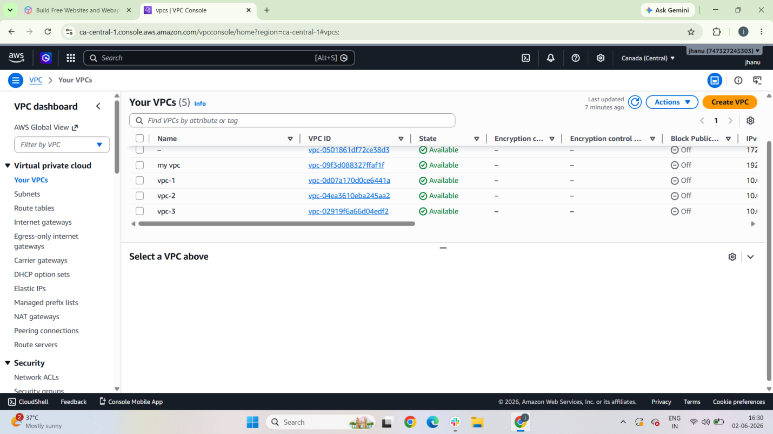

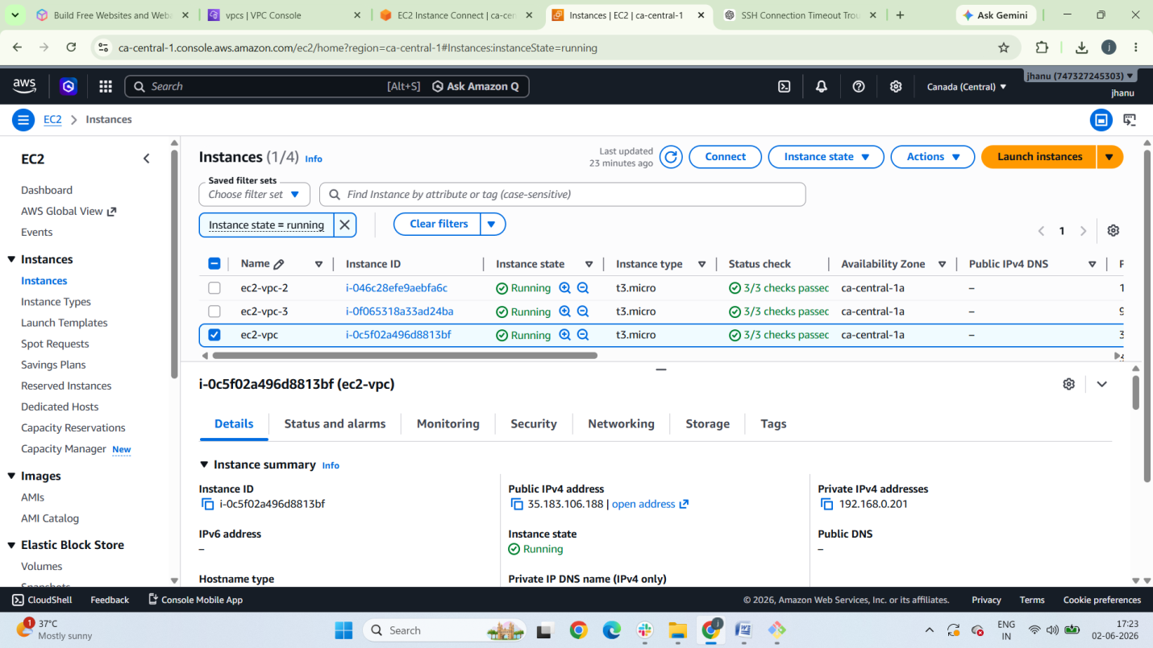
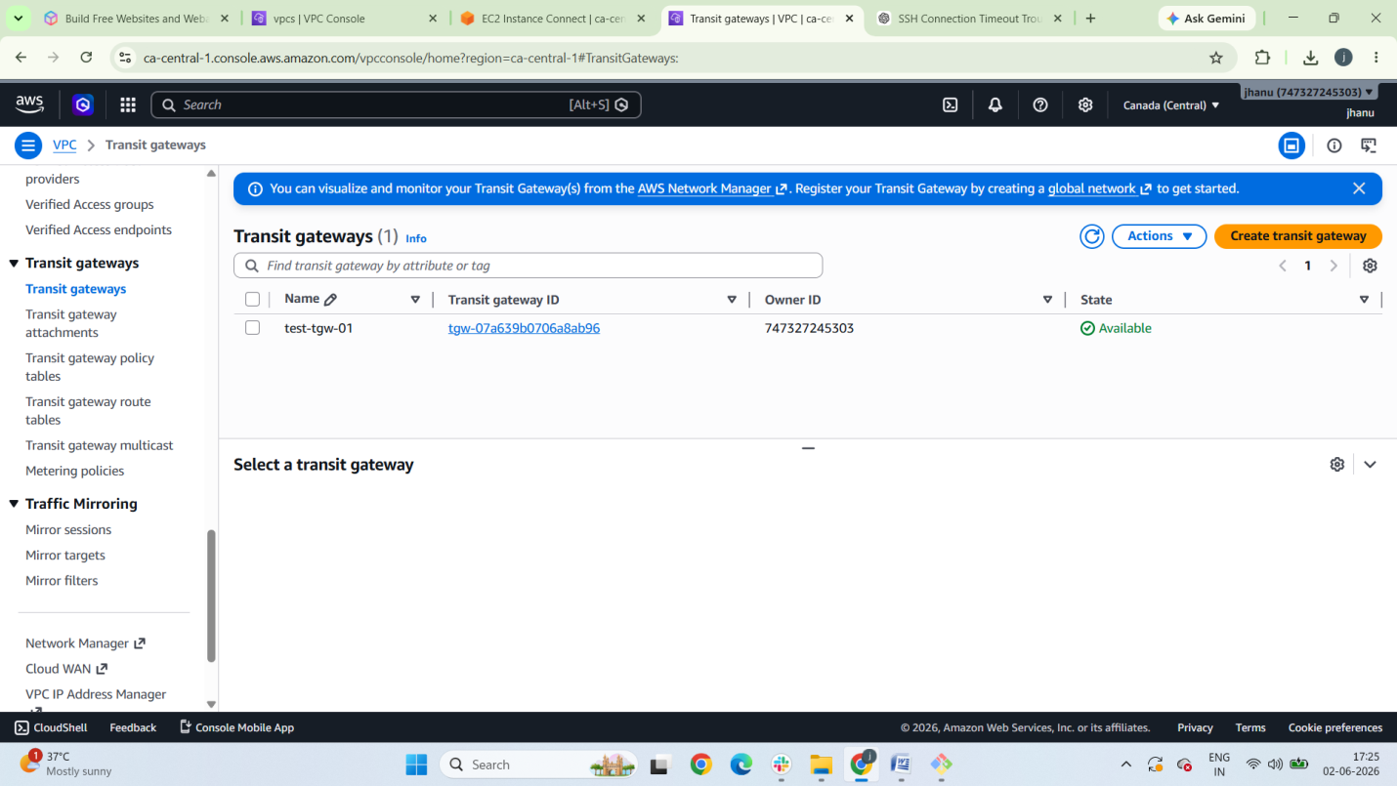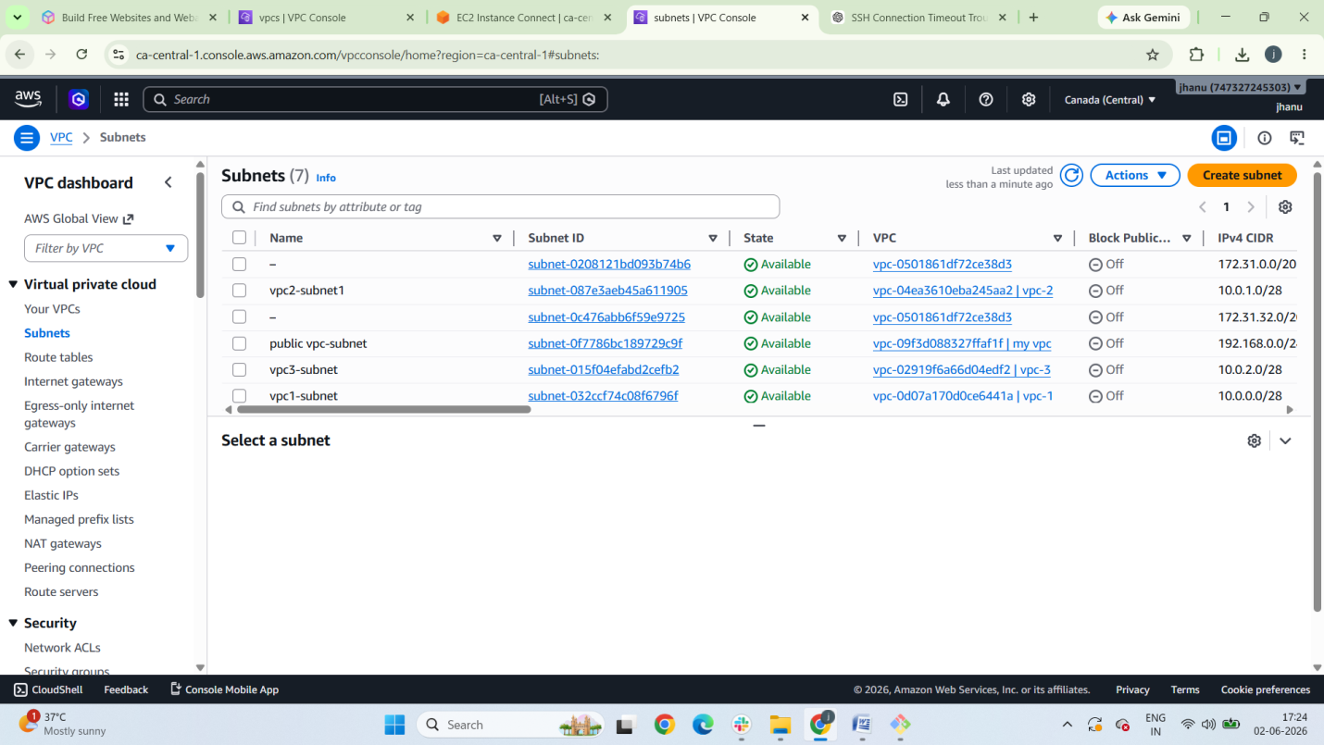

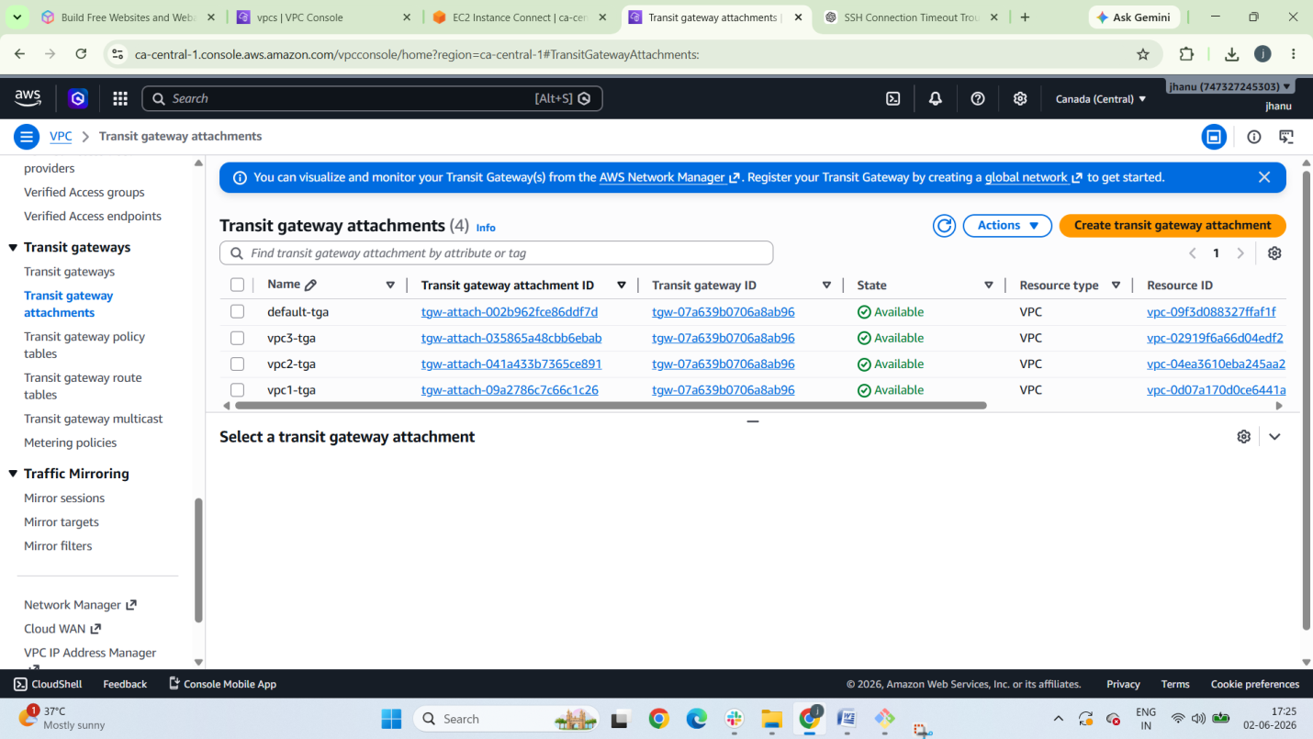
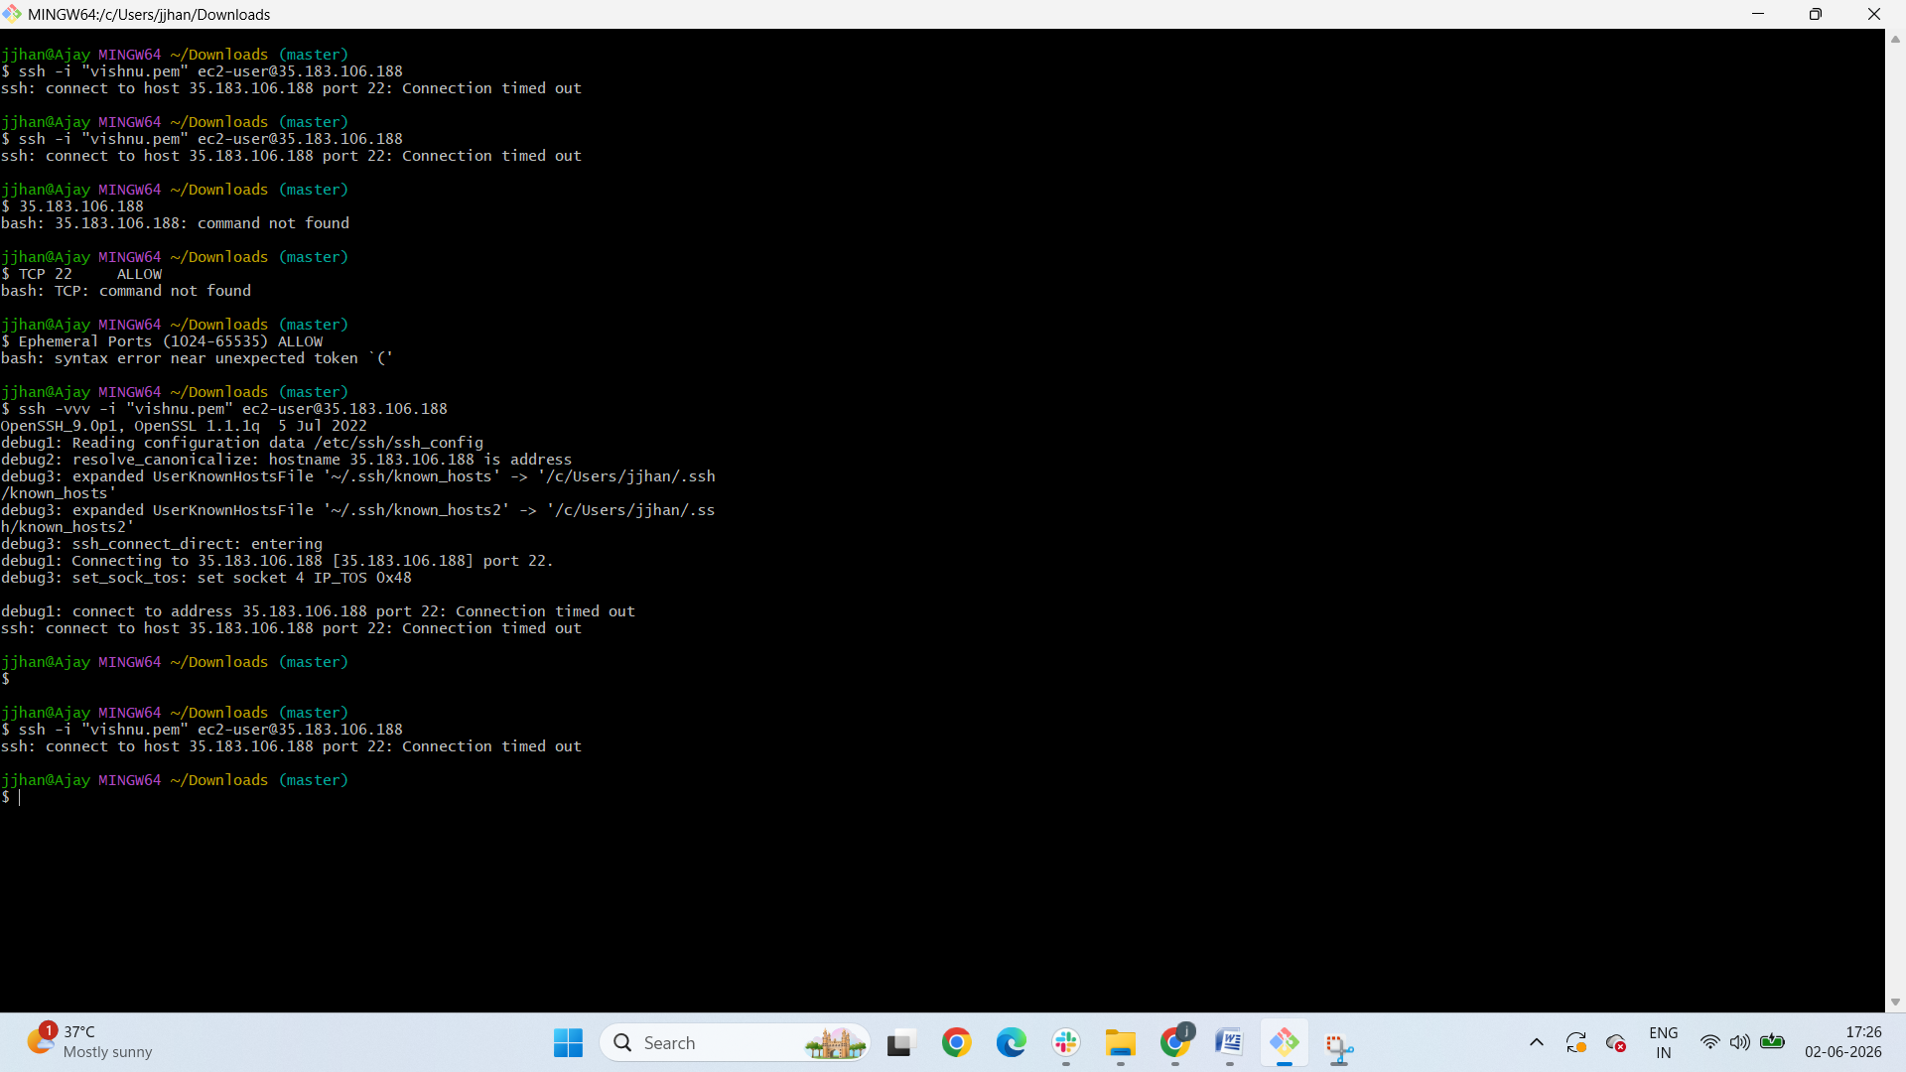
Vpc endpoint
A VPC Endpoint allows resources in your VPC (such as EC2 instances) to connect privately to AWS services without using the Internet Gateway, NAT Gateway, VPN, or Direct Connect.

Why use a VPC Endpoint?
Benefits include:
- ✅ Traffic stays within the AWS network.
- ✅ Improved security (no public internet exposure).
- ✅ Reduced NAT Gateway costs.
- ✅ Lower latency and better reliability.

Types of VPC Endpoints

1. Gateway Endpoint
Used for:
- Amazon S3
- Amazon DynamoDB
Route tables are updated automatically.
Example:
Private EC2 → S3 Bucket (without internet)

2. Interface Endpoint (AWS PrivateLink)
Used for most AWS services:
- Amazon EC2 API
- AWS Systems Manager
- Amazon CloudWatch
- AWS Secrets Manager
Creates an Elastic Network Interface (ENI) in your subnet with a private IP.

Architecture Example
Private EC2
│
▼
VPC Endpoint
│
▼
Amazon S3
Traffic never leaves AWS.

Hands-on: Create an S3 Gateway Endpoint
- Open VPC Console
- Click Endpoints
- Click Create Endpoint
- Select:
Service Category: AWS Services
Service Name: com.amazonaws.<region>.s3
Type: Gateway
- Select your VPC.
- Select the Route Table used by your private subnet.
- Create Endpoint.
AWS automatically adds a route similar to:
Destination: pl-xxxxxxxx
Target: vpce-xxxxxxxx

Verify from EC2
If AWS CLI is installed:
aws s3 ls
Even if the private subnet has:
No Internet Gateway
No NAT Gateway
the command will still work through the VPC Endpoint.

Common Use Case
Private EC2
│
├── S3 (via Gateway Endpoint)
├── SSM (via Interface Endpoint)
└── CloudWatch (via Interface Endpoint)
This allows a completely private architecture without public IPs.

Difference: Internet Gateway vs NAT Gateway vs VPC Endpoint
Feature | Internet Gateway | NAT Gateway | VPC Endpoint
Internet Access | Yes | Outbound Only | No
Public IP Required | Yes | No | No
Access AWS Services | Yes | Yes | Yes
Traffic Leaves AWS Network | Yes | Yes | No
Cost | Free | Charged | Gateway: Free, Interface: Charged
For AWS interviews, a common question is:
Why use a VPC Endpoint instead of a NAT Gateway?
Answer: A VPC Endpoint provides private access to AWS services over the AWS network, improving security and often reducing costs compared to routing through a NAT Gateway.

